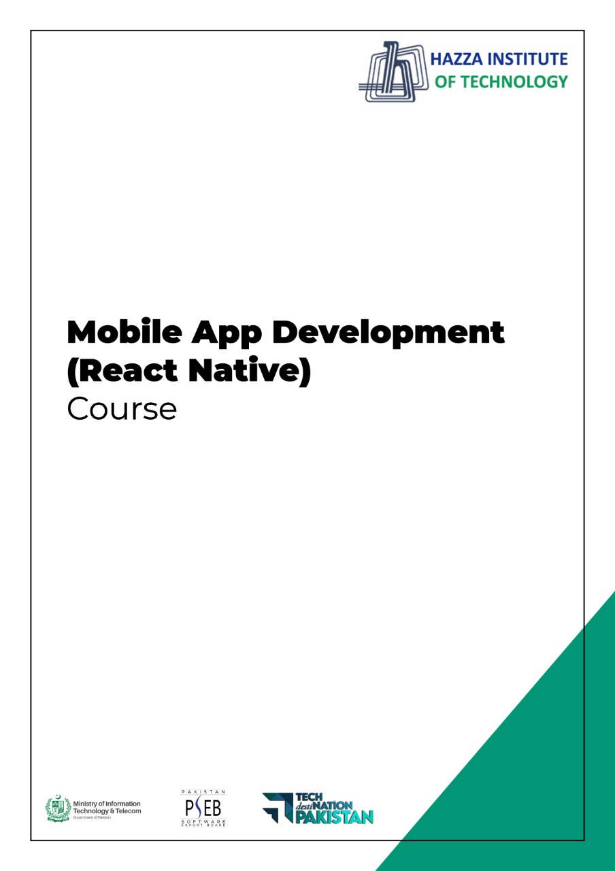

**(Flutter)**

Flutter Lab 4 (Session 2)

**Total Time:**

**3 hours**

**Pre-Lab Activities:**

* + Students should familier with layout widgets
  + Student should complete week three slides before this lab.

**Learning Outcomes:**

* + Student will learn about Layout Design
  + Student will learn single/multiple child widgets

**Student Activities:**

* + Student use the Android Studio for Flutter
  + Student use different layout widget to desgin UI

**Lab Tasks 3:**

* + Desing the User Interface according to given Layout

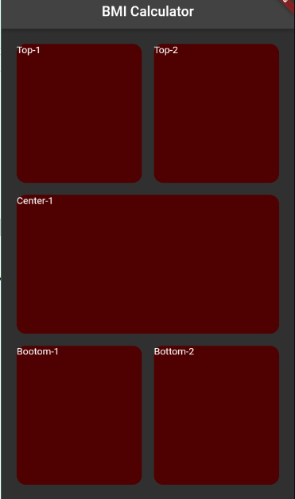

**Lab Solutions:**

**LAB 4.3 : Practicing Layout Designing.**

**CODE:**

|  |
| --- |
| body: Container(  margin: EdgeInsets.all(15),  child: Column(  children: [   Expanded(  child: Container(  child: Row(  children: [  Expanded(child: Container( margin: EdgeInsets.all(10),width: double.*infinity*, height: double.*infinity*, child: Text('Top-1'),  decoration: BoxDecoration(borderRadius: BorderRadius.circular(15), color: Color(0xFF4F0000)),),),  Expanded(child: Container( margin: EdgeInsets.all(10), width: double.*infinity*, height: double.*infinity*, child: Text('Top-2'),  decoration: BoxDecoration(borderRadius: BorderRadius.circular(15), color: Color(0xFF4F0000)))),  ],  ),  ),  ),  Expanded(  child: Container(  margin: EdgeInsets.all(10),   width: double.*infinity*,  height: double.*infinity*,  child: Text('Center-1'),  decoration: BoxDecoration(color: Color(0xFF4F0000), borderRadius: BorderRadius.circular(15)),),),   Expanded(  child: Container(  child: Row(  children: [  Expanded(child: Container(margin: EdgeInsets.all(10), width: double.*infinity*, height: double.*infinity*, child: Text('Bootom-1'),  decoration: BoxDecoration(color: Color(0xFF4F0000),borderRadius: BorderRadius.circular(15)),)),  Expanded(child: Container(margin: EdgeInsets.all(10), width: double.*infinity*, height: double.*infinity*, child: Text('Bottom-2'),  decoration: BoxDecoration(color: Color(0xFF4F0000), borderRadius: BorderRadius.circular(15)),)),  ],  ),  ),  ),  ],  ), |